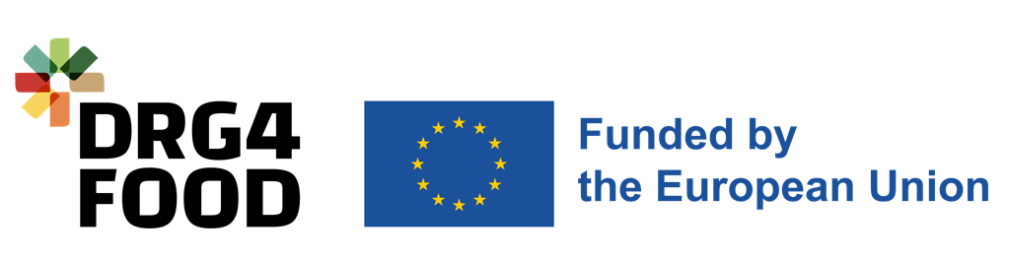

Annex D Consortium Declaration of Honour

DRG4Food – Open Call #1
[HORIZON-CL6-2022-GOVERNANCE-01-10] Project #: 101086523

  - Duration
  - End Date
  - Start Date

Consortium Declaration of Honour

Project title: _________________________________________________________
Project acronym: ____________________________________________________

BETWEEN

______________________________________________________________ [Organisation name] established in ____________________________________________________, [Official address], VAT number ____________________, acting as the consortium leader and represented for the purposes of signing the Consortium Declaration of Honour by ___________________________________ [Name of legal representative];

AND

______________________________________________________________ [Organisation name] established in ____________________________________________________, [Official address], VAT number ____________________, represented for the purposes of signing the Consortium Declaration of Honour by ___________________________________ [Name of legal representative];

AND [remove block below only if two entities participate in the consortium]

______________________________________________________________ [Organisation name] established in ____________________________________________________, [Official address], VAT number ____________________, represented for the purposes of signing the Consortium Declaration of Honour by ___________________________________ [Name of legal representative];

It is hereby agreed that:
- All information provided is true and legally binding.
- Partner ___________________________________________________ [Consortium leader name] is acting on behalf the following partner(s) as the consortium leader:
  - Partner 2: __________________________________________ [Organisation name]
[remove block below – Partner 3 – and this text if only two entities participate in the consortium]
  - Partner 3: __________________________________________ [Organisation name]

The consortium entities have agreed on their roles and budget shares.
- The consortium leader is solely responsible for distributing the budget shares to the other consortium partners in accordance with this Consortium Declaration of Honour.
- The DRG4FOOD consortium bears no responsibility in case a partner of this project consortium violates the mutual agreement set in this Consortium Declaration of Honour.
- The DRG4FOOD consortium bears no responsibility in the case of dispute among consortium partners regarding intellectual property rights.
- By signing this Consortium Declaration of Honour, all consortium partners declare that they are not members of any other consortium in the DRG4FOOD - Open Call #1. In case any entity, consortium leader or partner, participates in more than one consortium, both consortia will be excluded. In addition, partners confirm that the project has not received funding from multiple sources.
- By signing and submitting this Consortium Declaration of Honour, the consortium partners accept all the rules explained in Annex A: DRG4Food Guidelines for Applicants.
- All partners declare not being in one of the following situations:
- Is bankrupt or being wound up, is having its affairs administered by the courts, has entered into an arrangement with creditors, has suspended business activities, is the subject of proceedings concerning those matters, or is in any analogous situation arising from a similar procedure provided for in national legislation or regulations.
- It or persons having powers of representation, decision making or control over it have been convicted of an offence concerning their professional conduct by a judgment which has the force of res judicata.
- It has been guilty of grave professional misconduct proven by any means which the contracting authority can justify including by decisions of the European Investment Bank and international organisations.
- It is not in compliance with its obligations relating to the payment of social security contributions or the payment of taxes in accordance with the legal provisions of the country in which it is established or with those of the country of the contracting authority or those of the country where the contract is to be performed.
- It or persons having powers of representation, decision making or control over it have been the subject of a judgement which has the force of res judicata for fraud, corruption, involvement in a criminal organisation or any other illegal activity, where such illegal activity is detrimental to the Union’s financial interests.
- Is subject to an administrative penalty for being guilty of misrepresenting the information required by the contracting authority as a condition of participation in a grant award procedure or another procurement procedure or failing to supply this information or having been declared to be in serious breach of its obligations under contracts or grants covered by the Union's budget.
- Each partner declares that:
- It is not subject to a conflict of interest.
- Has not made false declarations in supplying the information required as a condition of participation in the DRG4FOOD - Open Call #1 or does not fail to supply this information.
- It is not in one of the situations of exclusion, referred to in the above-mentioned points a) to f).
- Is aware and fully accepts all DRG4FOOD conditions and rules as expressed in all DRG4FOOD - Open Call #1 open call documents.
- Each partner certifies that:
- It is committed to participate in the above mentioned project.
- Has stable and sufficient sources of funding to maintain its activity throughout its participation in the above-mentioned project and to provide any counterpart funding necessary.
- Has or will have the necessary resources as and when needed to carry out its involvement in the above- mentioned project.

Consortium Leader (Lead Beneficiary)
Organisation full name
Organisation short name
Full address
Country
Name of legal representative
Position in the Organisation
Project budget share | _________EUR

Legal representative signature and stamp
(stamp if applicable)

Done at (place) ______________, on the _____ (day) _____ (month) _____ (year)

Consortium Partner no. 2
Organisation full name
Organisation short name
Full address
Country
Name of legal representative
Position in the Organisation
Project budget share | _________EUR

Legal representative signature and stamp
(stamp if applicable)

Done at (place) ______________, on the _____ (day) _____ (month) _____ (year)

Consortium Partner no. 3 (if applicable)
Organisation full name
Organisation short name
Full address
Country
Name of legal representative
Position in the Organisation
Project budget share | _________EUR

Legal representative signature and stamp
(stamp if applicable)

Done at (place) ______________, on the _____ (day) _____ (month) _____ (year)

