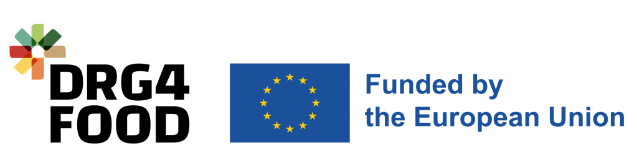

Annex C Declaration of Honor

DRG4Food – Open Call #2
[HORIZON-CL6-2022-GOVERNANCE-01-10] Project #: 101086523

  - Duration
  - End Date
  - Start Date

Applicant Declaration of Honour

Project title: _________________________________________________________
Project acronym: _____________________________________________________

On behalf of __________________________________________ [Company/ organisation name] established in ___________________________________________, [Official address], VAT number ____________________, represented for the purposes of signing and submitting the proposal and this Declaration of Honour by ___________________________________ [Name of legal representative].

By signing this Declaration of Honour, I declare that:
- I have the power of legally binding the above-mentioned organisation to this proposal.
- Neither the above-mentioned entity nor any linked entity or any individual member of the proposal team has submitted any other proposal under the DRG4Food - Open Call #2. In case the above-mentioned entity or any individual member of the team has submitted more than one proposal to this open call, all associated proposals will be automatically excluded from the evaluation process.
- I and the above entity that I legally represent are fully aware and duly accept all DRG4Food - Open Call #2 rules and conditions as expressed in the respective open call documents and Annexes and will respect any evaluation decision and proposal selection.
- The information included in the Annex E: SME Declaration document is true and legally binding (applicable to SMEs).
- All provided information in this declaration is true and legally binding.
- I give the consent and permission to the DRG4Food - Open Call #2 coordinator to use the attached information to contact me for any issue associated with the associated proposal.

Declaration Of Honour On Exclusion Criteria and Absence Of Conflict Of Interest

By signing this Declaration of Honour, I declare that all provided information below is true and legally binding both for me and for the entity that I legally represent:
- I declare that the mentioned entity is not in one of the following situations:
- Is bankrupt or being wound up, is having its affairs administered by the courts, has entered an arrangement with creditors, has suspended business activities, is the subject of proceedings concerning those matters, or is in any analogous situation arising from a similar procedure provided for in national legislation or regulations.
- It or persons having powers of representation, decision making or control over it have been convicted of an offence concerning their professional conduct by a judgement which has the force of res judicata.
- Has been guilty of grave professional misconduct proven by any means which the contracting authority can justify including by decisions of the European Investment Bank and international organisations.
- Is not in compliance with its obligations relating to the payment of social security contributions or the payment of taxes in accordance with the legal provisions of the country in which it is established or with those of the country of the contracting authority or those of the country where the contract is to be performed, to be proved by the deliverance of official documents issued by the local authorities, according to the local applicable rules.
- It or persons having powers of representation, decision making or control over it have been the subject of a judgement which has the force of res judicata for fraud, corruption, involvement in a criminal organisation or any other illegal activity, where such illegal activity is detrimental to the Union’s financial interests.
- Is subject to an administrative penalty for being guilty of misrepresenting the information required by the contracting authority as a condition of participation in a grant award procedure or another procurement procedure or failing to supply this information or having been declared to be in serious breach of its obligations under contracts or grants covered by the Union's budget.
- I declare that the natural persons with power of representation, decision-making or control over the above-mentioned entity are not in the situations referred to in (a) to (f) above.
- I declare that:
- Neither I or any other person I know from the entity is subject to an DRG4Food project conflict of interest.
- Neither I or any other person I know from the entity participates, controls, submits, or is associated in any way with more than one proposal to the DRG4Food - Open Call #2.
- I have not made false declarations in supplying the information required by participation in the open calls of the DRG4Food project or does not fail to supply this information.
- I am not in one of the situations of exclusion, referred to in the above-mentioned points 1 (a) to (f).
- I am aware and fully accept all DRG4Food conditions and rules as expressed in the all DRG4Food - Open Call #2 documents.
- I certify that the entity that I represent:
  - Is committed to participate in the above-mentioned project.
  - Has stable and sufficient sources of funding to maintain its activity throughout its participation in the above-mentioned project and to provide any counterpart funding necessary.
  - Has or will have the necessary resources as and when needed to carry out its involvement in the above- mentioned project.
Representative and organisation information:
Title (Mr., Ms., Dr.)
Name
Surname
Full address
Country
E-mail address
Telephone/ Mobile phone

Representative’s full name  _______________________________________ | Signature and stamp (if applicable)
Done at (place) ______________, on the _____ (day) _____ (month) _____ (year)

