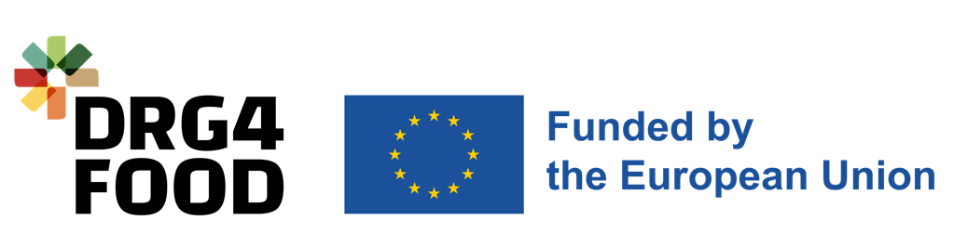

Annex G Bank Account Information

DRG4Food – Open Call #2
[HORIZON-CL6-2022-GOVERNANCE-01-10] Project #: 101086523

  - Duration
  - End Date
  - Start Date

Account Holder Information
Account Name Holder
The name or title under which the account has been opened and NOT the name of the authorized agent.
Holder’s Address
Postcode
Town/City
Country
Keywords

Bank Account Information
Bank Name
Branch Address
Postcode
Town/City
Country
IBAN number / Account number
Format example: ES76 2077 0024 0031 0257 5766
SWIFT code
8 to 11 characters

BANK STAMP + SIGNATURE OF BANK REPRESENTATIVE  The bank stamp + signature of the bank representative can be replaced with the attachment of a recent bank statement (less than 2 months). | DATE + SIGNATURE OF ACCOUNT HOLDER  (MANDATORY)

